Software design

1.Submission

Group_1

Julia Harttunen H291740

Verna Leisti H274423

Krista Mätäsniemi H292064

Eero Tarri H283568

# The structure

The application uses Qt implementation of MVC as structure. View for displaying and model for communicating with source of data. Delegate renders the items of data.

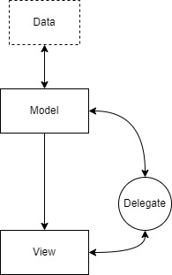

# Most important components

View is responsible for communication between user and the application. It receives user input and displays chosen data. Model is responsible for communicating with sources of data and logic. It fetches data from source interfaces, manipulates it, and sends to view for display. Works as a unified adapter to data.

Delegate renders the data for view and supports editing data for model.

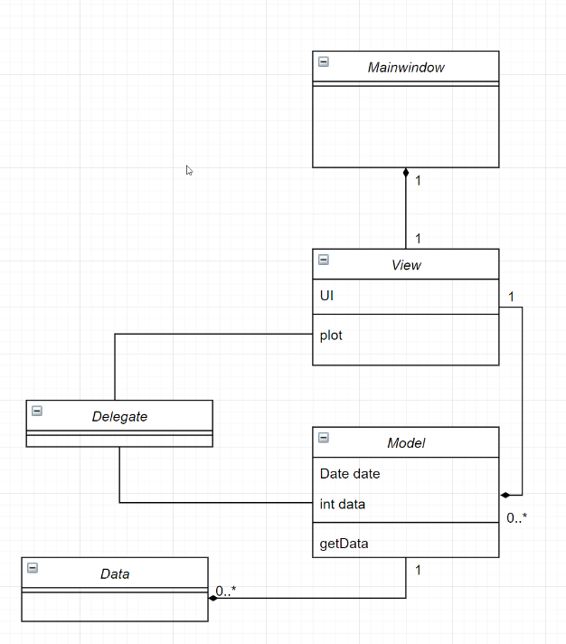

# Most important interfaces

SMEAR API is an interface for the model to get recent data from SMEAR.

STATFI API is an interface for the model to get historical data from STATFI.